The Elevator

| Author | Ben Artus |
| --- | --- |
| Created | 3/23/25 |
| Reviewers |  |
| Version Notes | (3/23/25) 1.0 - First draft |

## Introduction

The Elevator application simulates the functionality of individual elevators and the operation of multiple elevators in a group (aka. elevator bank). This system accounts for different types of users with different priority and access levels. It also accounts for different operating modes.

## Features and Requirements

* An elevator can move up, down, or stay stationary.
* Elevators should arrive (<30s wait time) and take passengers to their destination floor as quickly as possible (<60s travel time)
* Controls to open, close, or hold the doors
* Doors should only open when the elevator is stationary at a landing
* If the elevator has a scale, it should check current weight load against max recommended value

### External Components

* **Up** Call Button
* **Down** Call Button
* **Firefighter Panel** - Typically only on the ground floor at the main egress, contains a keyhole to put the elevator in Phase 1 emergency setting.

### Internal Components

* Standard Panel
  + **Floor Number** Button - Numbered buttons that correspond to each floor landing the elevator services.
  + **Open Door** Button
  + **Close Door** Button
  + **Hold Door** Button - Holds the elevator and doors open for a prolonged period of time, often for freight loading or other accessibility reasons.
  + **Alarm** Button - Starts an audible alarm that signals an emergency, and will also send a signal to security or monitoring personnel.
  + **Emergency Stop** Button - Brings the elevator to an immediate stop, doors remain closed.
  + **Call** Button - Connects to emergency or security personnel via a dedicated two-way speaker call system.
* Firefighter Panel
  + **Keyhole** - Allows elevator to be put into phase 2 emergency mode, which alters door open/close functionality. Removal of the key returns the elevator to the main egress floor and back to Phase 1 emergency setting
  + **Open** Door Button- Press and hold until the door is fully open to stay open, else door will automatically close for safety
  + **Close** Door Button
  + **Push/Pull** Button - Force stop or force the car to run
* Floor Display Panel - Small lit panel that displays the floor number and which direction the elevator is currently heading.
* Keycard Reader - Requires users to scan their keycard (i.e. hotel room keycard) in order to use the elevator or access special floors, depending on configuration.
* Audio System - Speaker system that plays overhead in the elevator.
  + Music
  + Announcements/Instructions for accessibility, providing audio cues such as the current floor, direction of the elevator, emergency directions, or other important info about the elevator’s operational state.
* Scale - Elevators have a maximum operational weight capacity. This would trip a failure state and not allow the elevator to proceed while overloaded.

### Operating Modes

* Standard
  + **Default** - Open to the public, normal operations
  + **Secure** - Requires keycard access
  + **Fire Service** - First responder mode for firefighters, requires special key
* Special3
  + **Anti-Crime Protection** - Elevator stops at a specified security landing for inspection
  + **Up-Peak** - Maximize efficiency for incoming traffic going up into the building
  + **Down-Peak** - Maximize efficiency bringing traffic down to exit the building
  + **Sabbath** - Elevator does not require interaction, stops at every floor
  + **Independent** - Usually reserved for special groups or loading operations, removes the elevator from regular dispatch
  + **Inspection** - Used for maintenance and inspections
  + **Medical Emergency** - Also called “code blue mode”, allows for priority access by medical personnel to respond to emergency medical situations
  + **Riot** - Prevents the elevator from stopping in parking or the lobby, but allows continued use on other levels by building occupants

### Users

* **Passenger** - Calls for an elevator, inputs destination floor and rides to destination. Access may be restricted by keycard.
* **Staff** - Use of the elevators is similar to a public passenger, but they have expanded access and the ability to put elevators into specialized modes.
* **Maintenance** - Require special access and operation modes during repairs or inspections. They may need to run the elevators with doors open to gain access to the bottom/top of the elevator equipment.
* **First Responder** - Makes use of special modes and emergency panels, altering elevator functionality from the standard passenger use-case.

### System Dispatch4

* **Collective Operation** - Services all calls in one direction, then reverses to serve calls in the opposite direction
* **Nearest Car** - The closest car (by distance) to the call is dispatched
* **Estimated Time of Arrival** - The car that can arrive soonest to the caller is dispatched
* **AI/ML Group Controls** - Many dispatch systems today use AI/ML to fine tune dispatching. They can get quite complex and exact algorithms are usually proprietary.

### Assumptions

Elevator speed, dispatching, size, weight load, operation modes, and number vary depending on the type of building: Commercial vs hospitality, multi-family complexes vs healthcare.2

This simulator design will also assume that the elevator(s) only serve numbered floors, so there are no basement or parking levels. It will also assume that the ground floor is the main egress, making the ground floor the place for the external firefighter keyhole access.

Averages (Defaults)

* Plan for at least 1k trips per year per elevator (each person x 4 trips daily x 250 days)1
* Average of 4 landings1
* 1-8 elevators per bank2

Maximum Values

* Handle up to 500k trips per year for each elevator (busiest elevator in the world makes around ~450k)
* Handle up to 250 landings in service (tallest building is 163 floors)
* Accommodate up to 80 elevators in a bank (tallest building has 57)
* In this case, we will assume a maximum operating weight of 2,270kg/5,000Ibs.

### References

1. [NEII Docs](https://nationalelevatorindustry.org/wp-content/uploads/2020/07/NEII-Fact-Sheet-2020.pdf)
2. [Elevators Per Building A Personal Guide - Modular Elevator Manufacturing](https://modularelevator.net/elevators-per-building/)
3. [Elevator - Wikipedia](https://en.wikipedia.org/wiki/Elevator)
4. [Elevator_Dispatching.pdf](https://download.peters-research.com/library/Elevator_Dispatching.pdf)

## Architecture

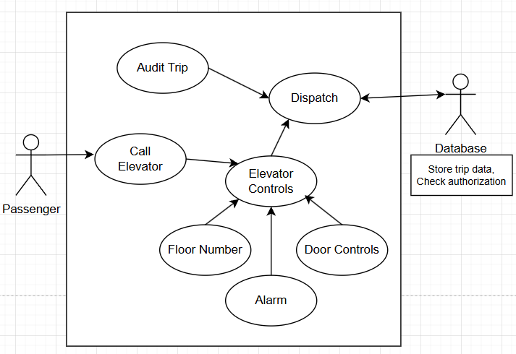

### 

### Database Tables

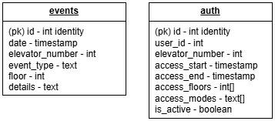

**Events** - Tracks all of the audit events whenever an elevator is accessed. This would include trips, access, floor, changes to operating mode, and any button press alerts.

**Auth** - If security access controls are implemented (ex. Keycard access), any attempts to change operational mode or use the elevator will be checked for authorization.

### Enums

### 

### Classes

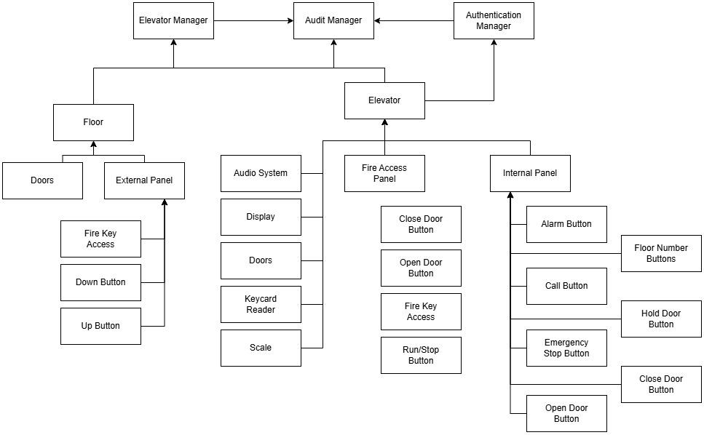

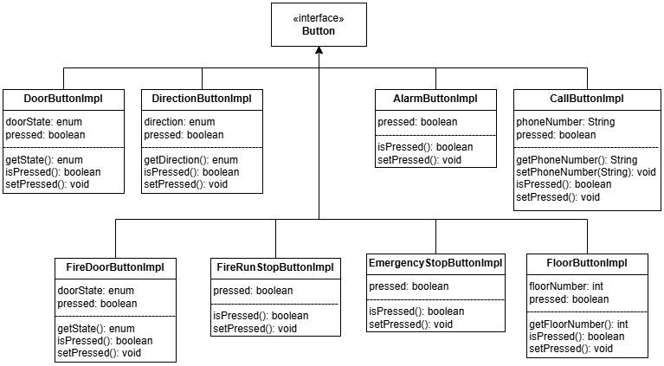

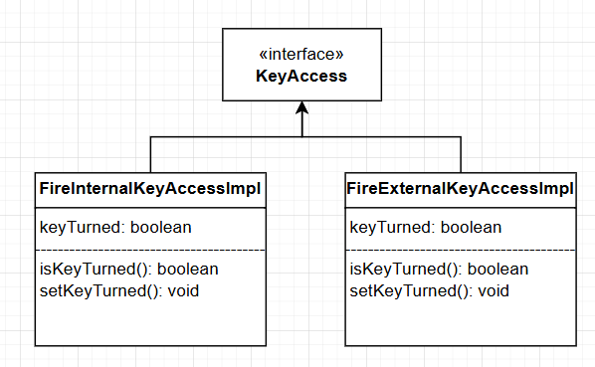

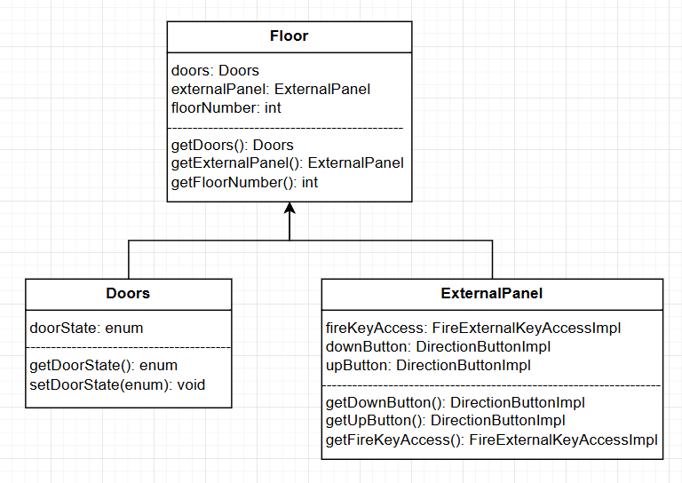

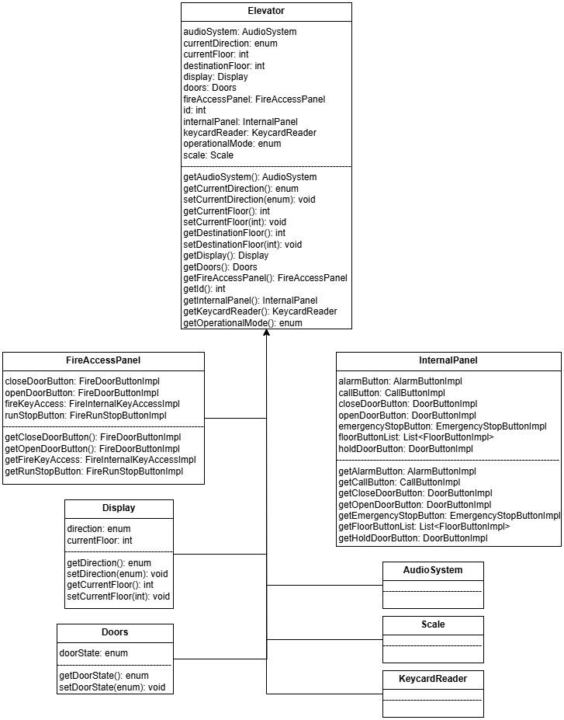

### 

### 

### Elevator Dispatch

This simulator will use a simple method of dispatching the closest elevator, regardless of direction. Enhancements would include more detailed information like load weight and other adaptive traffic data. It would also add some kind of queuing for multiple stops along the way, picking up passengers going the same direction and dropping each along the way to the final stop.

In order to more quickly find a matching elevator, the floors are divided into buckets of 5 floors (ex. 12 floors would be divided into 3 buckets: 1-5, 5-10, 10-12). The dispatcher will check for an available elevator in the bucket of incoming service calls, and work its way out from there. So if a request comes in for pickup on the 3rd floor, the dispatcher would check bucket 0 first, then move on to bucket 1 and finally 2.